

RVR PIPES AND DRUMS
ASSOCIATION INC.

Annual “ Touch of Scotland” Luncheon

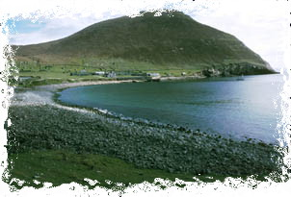

Over a century and a half ago a group of hardy islanders departed the ocean tossed Isle of St Kilda in the Atlantic Ocean west of Scotland. They were seeking a new life far away from the craggy island they called home. Some of them travelled to the other side of the globe and to help keep the memory of their forebears alive.

We hope you will join us for a relaxed luncheon at the

Box Hill R.S.L. (Upton Room)
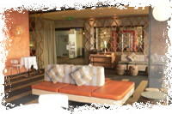
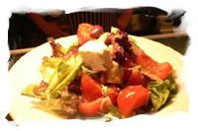

26 Nelson Rd. Box Hill
(Opposite Epworth Eastern
Parking available at R.S.L.)
Sunday, 25th May 2008

Cost : $48 per person
Starting from 12.30 PM
Normal bar service.
Dress – Smart Casual Featuring 5/6 Pipes and Drums RSVP 14th May, 2008

For bookings, please complete the form below and fax or mail your details to
the attention of our Treasurer, Mr Ben Tosetto.

The Treasurer,  RVR Pipes & Drums Association Inc.,  C/- P.O. Box 233  SOUTH MELBOURNE VIC 3205  BH Ph: 03 9690 6800  FAX Ph: 03 9696 3865 | Name/Organisation:  …………………………………….…..…………..……..  Mailing Address:………………….............….…….…  ……………………………………….…..…….………...  B.H. Phone No:…..………..…………….……….  No. of persons attending :……………..  Cheque/Money Order Enclosed: $__________
http://intergon.net/rvrpd

